RESUME 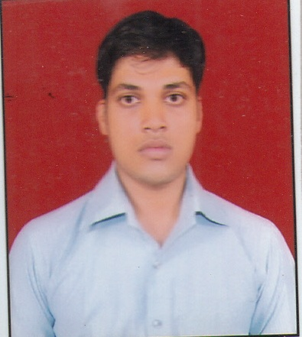

Mobile: 9628534052
Email: sharmaanshul049@gmail.com

ANSHUL SHARMA

CAREER OBJECTIVE

To work as a trainee of management in fast growing and reputed organization, where my knowledge in management with finance and marketing may be developed and may showcase my potential in finance and marketing to achieve a everlasting success.

PROFESSIONAL SUMMARY

M.B.A- Specialization in Finance & Marketing.
UNIVERSITY - Mahamaya Technical University, Noida(U.P.)
SESSION - 2011-2013

Skill Set/Profile
Basic Computer Knowledge (M.S. Word, Excel, Power point, internet)

EDUCATION

Class | Name of Institute | Year of Passing | Medium / Stream | Board / University | Agg%
X | Mother Teresa Higher Secondary School, Raebareli | 2006 | Science | UP Board | 1st
XII | Govt. Inter College Raebareli | 2008 | Commerce | UP Board | 1st
Graduation | Firoz Gandhi College, Raebareli | 2011 | B.com | CSJM University,kanpur | 2nd

MBA | I Sem | II Sem | III Sem | IV Sem | Agg.%
Division | 1st | 1st | 1st | 1st | 1st

INDUSTRIAL TRAINING, FINAL RESEARCH PROJECT & INDUSTRIAL VISITS

Industrial Training Completed in:- INDIAN TELEPHONE INDUSTRY,(RAEBARELI) in FINANCIAL PERFORMANCE OF ITI.

Research report:- A COMPARATIVE STUDY OF CUSTOMERS SATISFACTION TOWARDS HDFC BANK AND SBI BANK

Industrial Visits:- PARLE, MOTHER DAIRY& COCA COLA
EXTRACURRICULAR ACTIVITIES and AWARDS

Management games "SHASHREEK" organizing award.
First Prize in management game "UNNYAAN" in MBA,
Certificate of management activity "UNNYAAN" in MBA
Certificate of Bhartia Sanskrit Competition.
Certificate of DOS.

STRENGTHS
- Dedicated towards work
- Positive attitude
- Team Work
- Self Motivated

HOBBIES
- Travelling
- Listening music

AREA OF INTEREST
FINANCE
PERSONAL DETAIL
Name: Anshul Sharma
Mother's name: Mrs. Asha Sharma
Father's name: Lt. Mr. shriram Sharma
Date of birth: 19-apr-1992
Nationality: Indian
Sex: Male
Language: Hindi & English
Local Address: H.NO- 6368, GF,pocket1 new housing board colony sec 3,faridabad
Permanent address: L-II-81 Jawahar Vihar colony, Raebareli(U.P.)
Pin Code: 229001
Mobile no: 9628534052
DECLARATION

I hereby declare that the information given is all true to my belief and knowledge.

Date:

Place: Faridabad (ANSHULSHARMA)
NAME

